**Foot and mouth disease (FMD)**

**Synonyms** :( apthous fever ;eczema contagious )

**Definition** :FMD disease is an acute febrile highly contagious disease of cloven footed animals . it is characterized by vesicular eruption in the epithelium of buccal cavity ,tongue ,muzzle ,feet ,teats, and udder .in calves there is focal degeneration of cardiac and skeletal muscles which often lead to death .

**Etiology :**

1. FMD virus belong to the family (picornaviridae )small RNA virus member of genus (apthovirus)
2. 7 serological types: ( "O" "A" "C" Asia-1 and sat-1,sat-2 and sat -3)
3. The virus resistant to various external agent including common disinfectants ,the virus most stable in ph ranging from 7.4 to 7.6 .the virus can be activated after boiling over 15 minutes at 70 Co .the virus is resistant to alcohol, ether and chloroform .

**Mode of transmission :**

1. Rapid spread by direct contact with infected animals .
2. Virus may gain entrance in a herd from infected materials ,food stuff ,feeding ,utensils اواني water ect.
3. Spread through airway
4. In tropical area spread through the ingestion .
5. The infection impose a high spread during the **cooler season** .
6. All fomites like clothes ,harness عدة الفرس ,mangers معلف ,bedding الاغطية ,straw ,hay….ect.
7. Free living birds may carrying the infection.
8. The human movement and entry of visitors in the farm .
9. Carrier may transfer the virus from animal to animal

**Pathogenesis:-**

* The primary site of infection and replication of FMD is in the mucosa of the pharynx. The virus may also enter through skin lesions or the GI tract.
* Once distributed throughout the lymphatic system, the virus replicates in the epithelium of the mouth, muzzle, teats, feet, and areas of damaged skin (eg, knees and hocks of pigs).
* Vesicles then develop at the organs and rupture within 48 hr.
* More than 50% of ruminants that recover from illness and those that are vaccinated and have been exposed to virus can carry virus particles in the pharyngeal region—up to 3.5 yr in cattle, 9 mo in sheep, and >5 yr in African buffalo.

❖ **Clinical Signs in Cattle:**

* The disease is not fetal ,morbidity is 100% but mortality is less .and The incubation period (2-8) days**.**
  1. Fever, pyrexia, hyperthermia ( the virus shed in urine 24 hours before the fever).

1. slobbering and smacking lips. سيلان العاب ولحس الشفاه
2. shivering. يرتجف
3. tender and sore feet. تقرح القدم وانسلاخها
4. reduced milk yield and Mammary gland swelling, mass, hypertrophy udder,
5. sores and blisters on feet. تقرحات وفراقيس بالقدم
6. sudden, severe lameness
7. lies down frequently and is very unwilling to rise. الاضطجاع وعدم الرغبه بالوقوف
8. blisters may be found on the hoof ,dental pad and sometimes the tongue.
9. oral and Tongue ulcers, vesicles, erosions, sores, blisters, cuts, tears.
10. Arrhythmia, irregular heart rate, pulse.
11. Abortion or weak newborns, stillbirth.

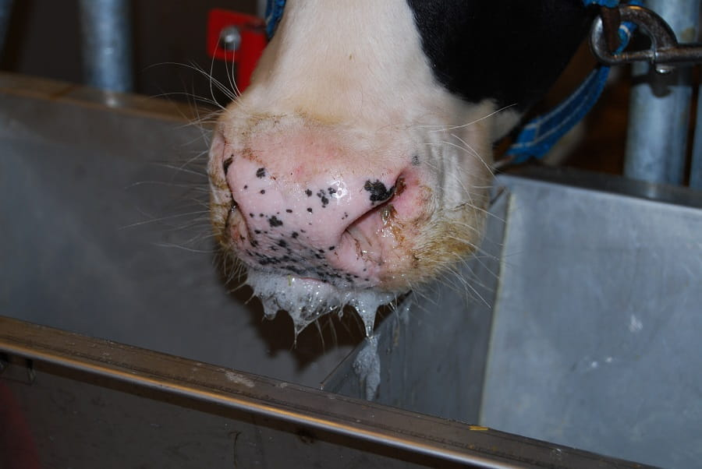

Profuse salivation and nasal discharge in cattle are significant clinical signs included in the FMD disease complex.

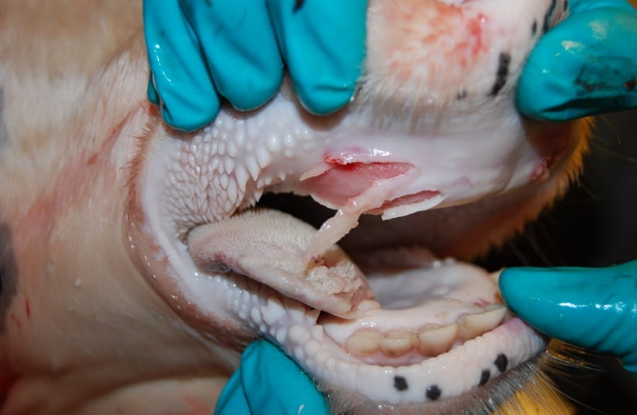

Erosive lesions on the dental pad and tongue of a cow. Vesicles have ruptured, and the overlying epidermis sloughed off. Hyperemia and hemorrhage in the underlying tissue follows. This was a contact animal on PID 10 within an experiment.

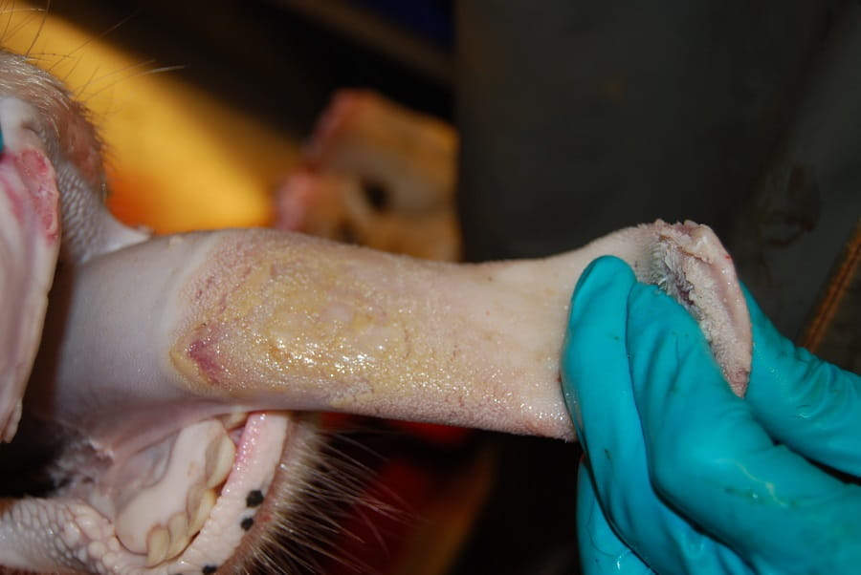

Healing lesion on bovine tongue. Contact animal on PID 10 within an experiment.

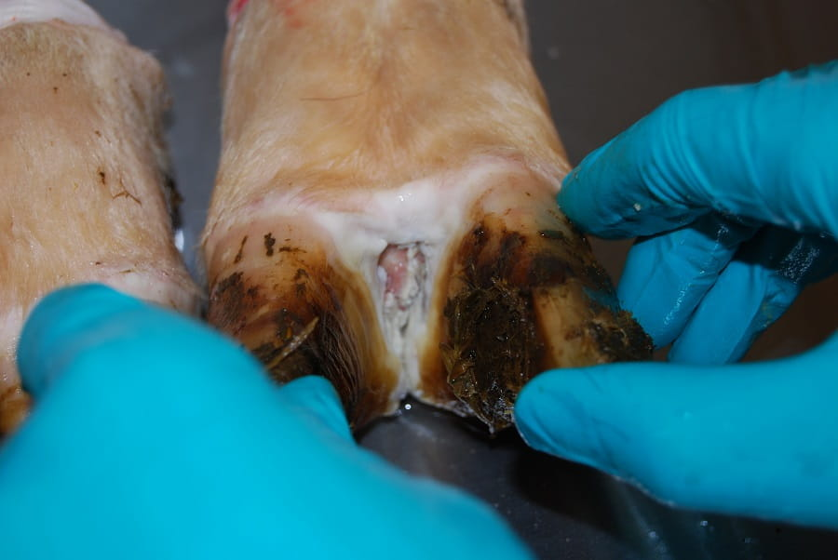

Erosive lesion in the interdigital cleft of a cow. Lesions may involve one or more feet. This was a contact animal on PID 4 within an experiment.

❖ **Lesions :**

1. Microscopically lesion will show intracellular oedema and necrosis of stratum spinosum layer of the epithelial cell .vesicular lesion become apparent when sufficient amount of fluid accumulate inside .
2. Vesicles or blisters on the tongue, dental pad, gums, cheek, hard and soft palate, lips, nostrils, muzzle, coronary bands, teats, udder, snout of pigs, corium of dewclaws and interdigital spaces
3. Heart muscle show degenerative change .there is gray or yellow foci or stick in the myocardium which is defined" Tiger heart" .change may also noted in the pancrease and large intestine .there is typical eroded in the rumen pillar.

❖ **Differential diagnosis:-**

1. Vesicular stomatitis.
2. Swine vesicular disease .
3. Vesicular exanthema of swine.
4. Rinderpest.
5. Bovine viral diarrhoea and Mucosal disease.
6. Infectious bovine rhinotracheitis.
7. Bluetongue
8. 8Epizootic haemorrhagic disease .
9. Bovine mammillitis.
10. Bovine papular stomatitis (Contagious ecthyma).
11. Malignant catarrhal fever**.**

❖ **Diagniosis :**

* Based on history ,clinical signs and laboratory diagnosis.

**Lab exam**. –

1. animal inoculation
2. complement fixation test (C.F.T.)
3. neutrilazation test (N.T.)
4. Agar gel diffusion precipitation test (A.G.P.T.)
5. flurescent antibody test (F.A.T.)
6. Tissue Culture Test(T.C.T)
7. ELISA.

**Treatment:**

* Treatment with mild disinfectants and protective dressing to inflamed area to prevent secondary infection is recommended in endemic countries, where a slaughter policy is not in force.
* A good symptomatic response to administration of flunixin meglumine.

**Prevention and control:**

● In endemic areas vaccination and quarantine are the basis for prevention and control. In free areas, the method of choice is rapid identification of an outbreak, quarantine and slaughter of all affected animals.

● Vaccine must be type specific. Most European and South American countries use trivalent inactivated vaccine against types A, O and C from cell culture virus. In Iraq vaccine should contain A, O and Asia 1 types of vaccine.

● Vaccine induced and naturally occurring immunity is short lived and vaccination must be repeated two to three times a year. Protection is partial so the infection usually results in sub clinical or mild disease.

● Calves nursing immune dams are likewise partially protected for up to 5 months. In an outbreak the most effective vaccine is autogenous.